

Department of

Bachelor of Computer Applications

**Ethical Hacking Fundamentals**

Lab File – CA 12

**Subject Code:** 19BCA4C02L

**Class:** IInd Year IInd Semester

**Prepared By:**

Suman Garai

20BCAR0246

**Aim :**

Practical to perform Network & Password Sniffing using Wireshark.

**Requirements :**

* Virtualisation Software
* Kali Linux 2022.1
* Basics of Wireshark
* Internet Connection

**Objectives :**

To capture packets and sniff data like password and username from vulnerable website

**Procedure :**

Basics

1. Since Wireshark comes pre-installed in Kali Linux, we are going to begin with searching it in Applications button.

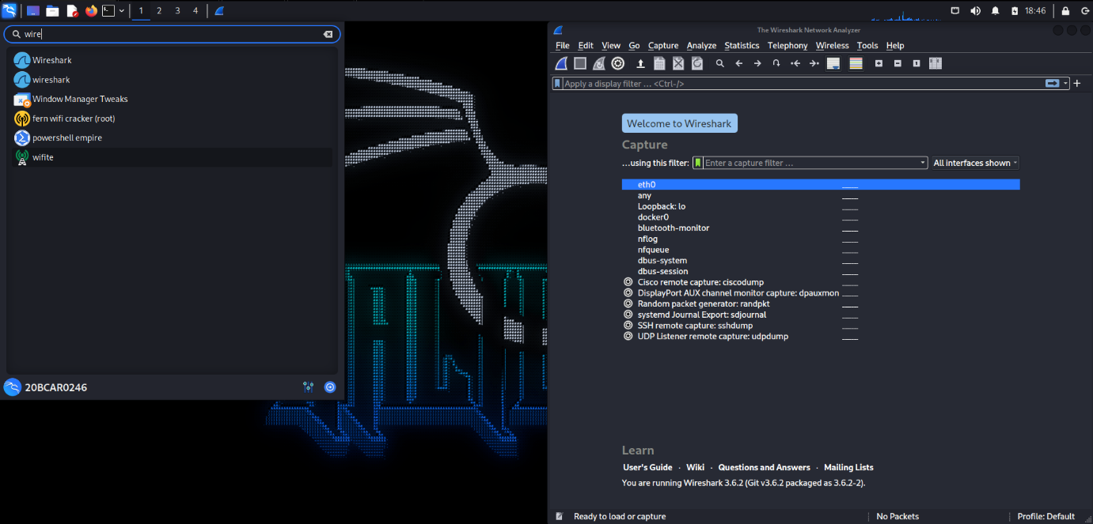

The window appears like this.

1. In Browser, head over to http://www.techpanda.org and login using the required credentials. Simultaneously, open eth0 to start capturing packet transferring.

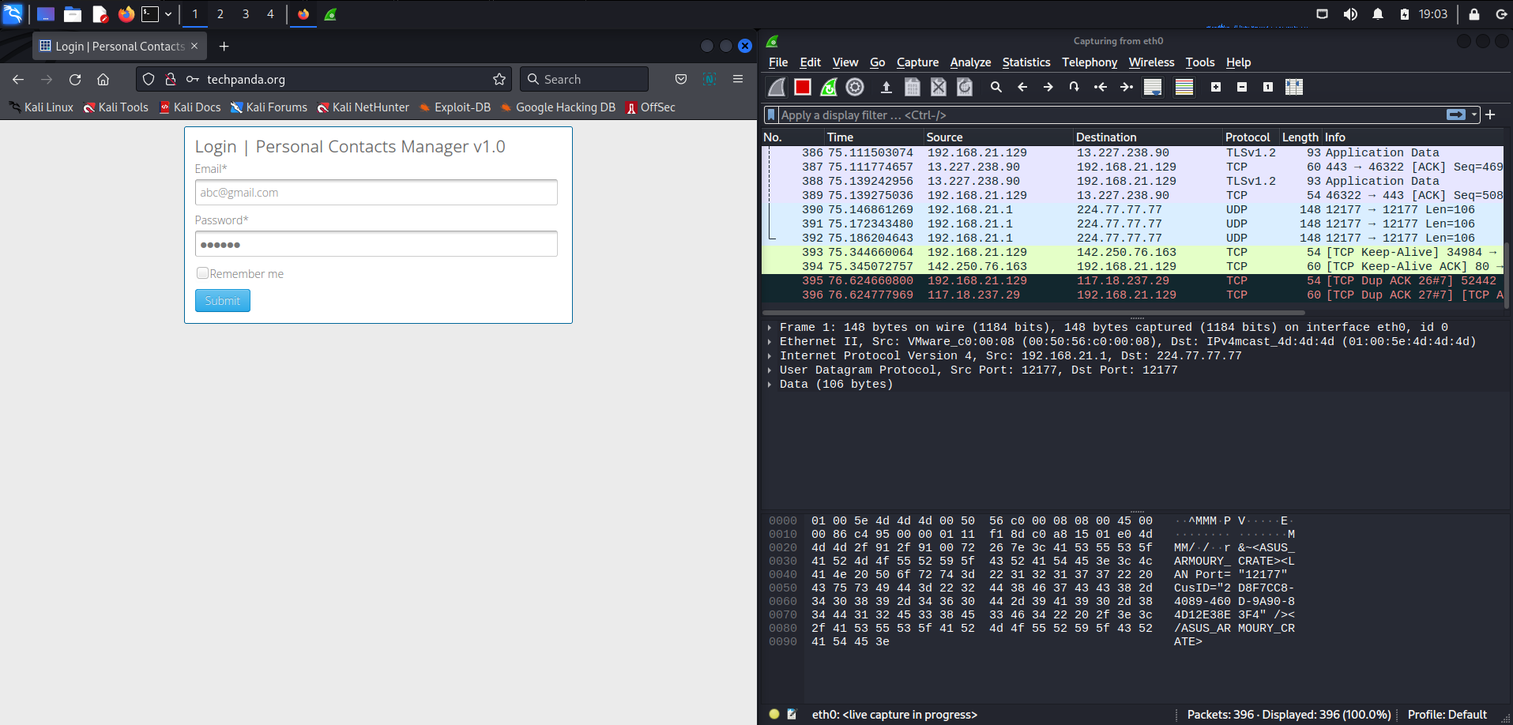

As we can see in the above image, every packet of ongoing transactions between the internet and the machine is being captured.

1. So, now, we will search in filters with http keyword. Double click on the entry which begins with Post as info after being logged into the website.

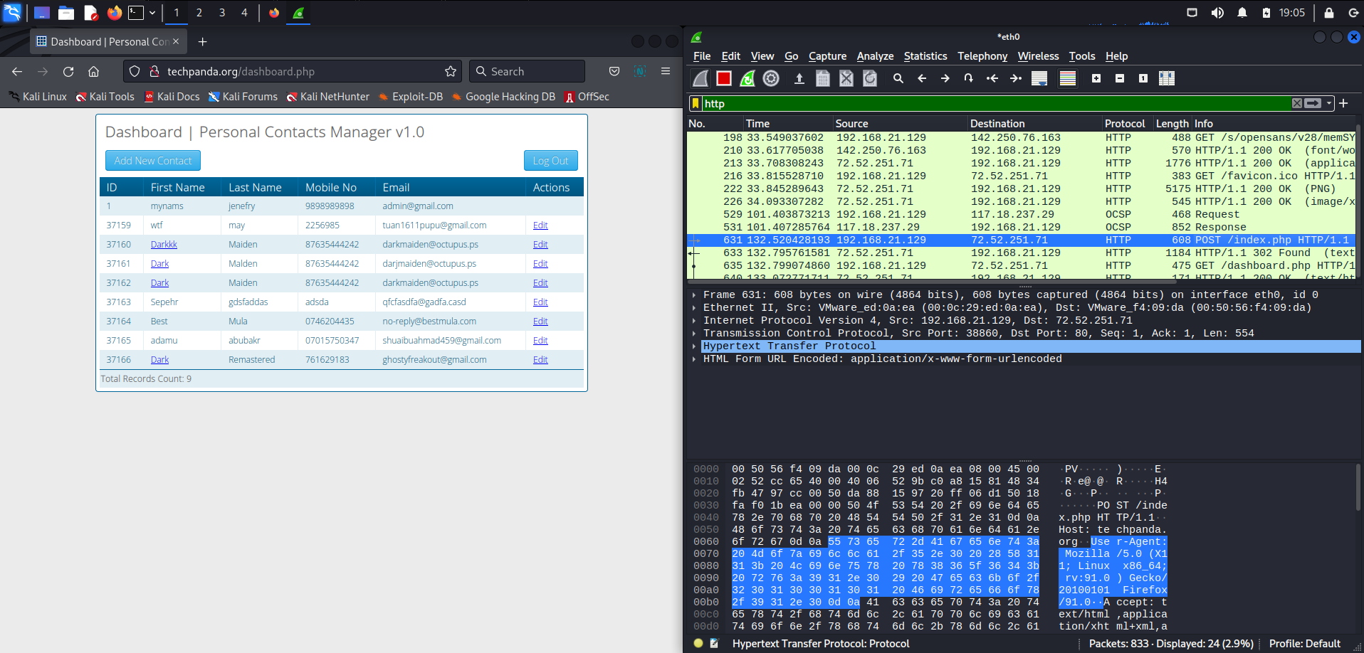

1. Opening HTML Form Encoded section we get our desired result.

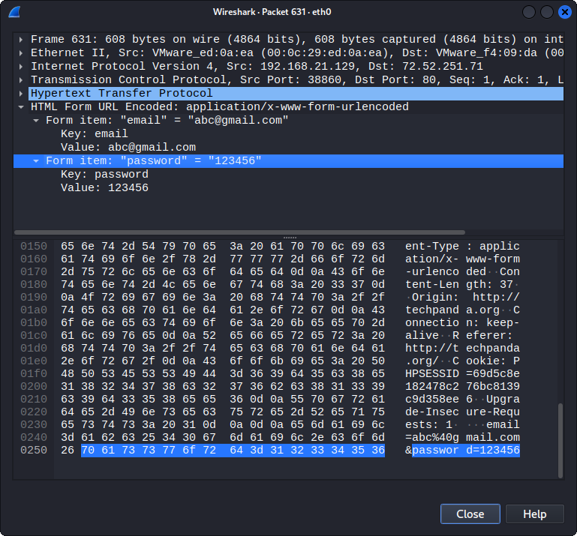

**Conclusion :**

In this practical, we used Wireshark to capture password on techpanda.org website. Wireshark is the world’s most foremost widely-used network protocol analyser. It helps to see what's happening on our network at a microscopic level and is the de facto standard across many commercial and non-profit enterprises, government agencies and educational institutions.